**AsSIGNMENT**

1) Find out standara deviation, mean, median, mode, quartile deviation, percentile deviation and decile deviation.

|  |  |  |  |  |  |  |  |  |  |  |  |
| --- | --- | --- | --- | --- | --- | --- | --- | --- | --- | --- | --- |
| **Class** | | **100--200** | | **200--300** | | **300--400** | | **400--500** | | **500--600** | |
| **Frequency** | | **8** | | **7** | | **41** | | **51** | | **14** | |
|  |  |  |  |  |  |  |  |  |  |  |  |
|  |  |  |  |  |  |  |  |  |  |  |  |
| **marks obtained** | | **10--20** | | **20--30** | | **30--40** | | **40--50** | | **50--60** | |
| **No. of Student** | | **25** | | **14** | | **58** | | **74** | | **14** | |
|  |  |  |  |  |  |  |  |  |  |  |  |
| **Class** | | **100--200** | | **200--300** | | **300--400** | | **400--500** | | **500--600** | |
| **Frequency** | | **15** | | **33** | | **63** | | **85** | | **100** | |

2) The following are the marks (out of 100) of 60 students in mathematics.  
16, 13, 5, 80, 86, 7, 51, 48, 24, 56, 70, 19, 61, 17, 16, 36, 34, 42, 34, 35, 72, 55, 75, 31, 52, 28,72, 97, 74, 45, 62, 68, 86, 35, 85, 36, 81, 75, 55, 26, 95, 31, 7, 78, 92, 62, 52, 56, 15,63,25,36,54,44,47,27,72,17,4,30.  
Construct a grouped frequency distribution table with width 10 of each class starting from 0 – 9.

3) find out mean, median, mode, quartiles, p69, p89, p10, d7 and D5, GM.

|  |  |  |  |  |  |  |  |  |  |  |
| --- | --- | --- | --- | --- | --- | --- | --- | --- | --- | --- |
| **a)** | **10** | **8** | **14** | **25** | **8** | **9** | **54** | **7** | **8** | **5** |
|  |  |  |  |  |  |  |  |  |  |  |
| **b)** | **58** | **41** | **25** | **77** | **22** | **54** | **58** | **24** | **86** | **54** |
|  |  |  |  |  |  |  |  |  |  |  |
| **c)** | **17** | **25** | **26** | **89** | **74** | **41** | **25** | **87** | **84** | **57** |
|  |  |  |  |  |  |  |  |  |  |  |
| **d)** | **10** | **33** | **96** | **13** | **78** | **54** | **26** | **35** | **95** | **55** |
|  |  |  |  |  |  |  |  |  |  |  |
| **e)** | **85** | **26** | **24** | **98** | **88** | **74** | **58** | **96** | **33** | **66** |
|  |  |  |  |  |  |  |  |  |  |  |
| **f)** | **25** | **88** | **74** | **58** | **78** | **52** | **58** | **65** | **65** | **21** |

4) The rank in statistics and accountancy of 10 students are given in brackets. Find the rank correlation co-efficient.

(8,3), (1,5), (6,2), (3,9), (2,10), (5,1), (4,6), (10,4), (9,7), (7,8)

1. Find the correlation co-efficient and covariance and coefficient of determination.

|  |  |  |  |  |  |  |  |  |  |  |
| --- | --- | --- | --- | --- | --- | --- | --- | --- | --- | --- |
| X | 20 | 29 | 21 | 28 | 22 | 27 | 23 | 26 | 24 | 25 |
| Y | 16 | 21 | 16 | 20 | 17 | 19 | 17 | 19 | 18 | 17 |

|  |  |  |  |  |  |  |  |  |  |  |  |  |
| --- | --- | --- | --- | --- | --- | --- | --- | --- | --- | --- | --- | --- |
| X | 66 | 40 | 35 | 75 | 65 | 80 | 35 | 20 | 85 | 65 | 55 | 33 |
| Y | 30 | 55 | 68 | 28 | 76 | 25 | 80 | 85 | 20 | 35 | 45 | 65 |

1. Find co-efficient of correlation from following results:

Average of x=10.5

Average of y = 13.9

S.D. of x = 3.5

S.D. of y = 4.1

N = 10, E(x- $\overline{x}$)(y- $\overline{y}$)=1364.

1. Find co-efficient of correlation from following data:

N=20, S.D. of x = 16, S.D. of y = 2.5, E(x- $\overline{x}$)(y- $\overline{y}$)=400.

1. Interprets the value of r=-1, 0 and +1 with the help of scatter diagram.

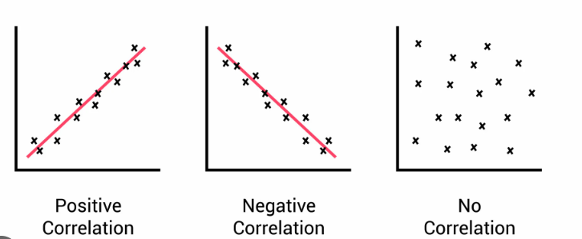

1. Explain meaning of the following terms:
2. Coefficient of determination
3. Scatter Diagram

**Probability practical with solution:**

1)

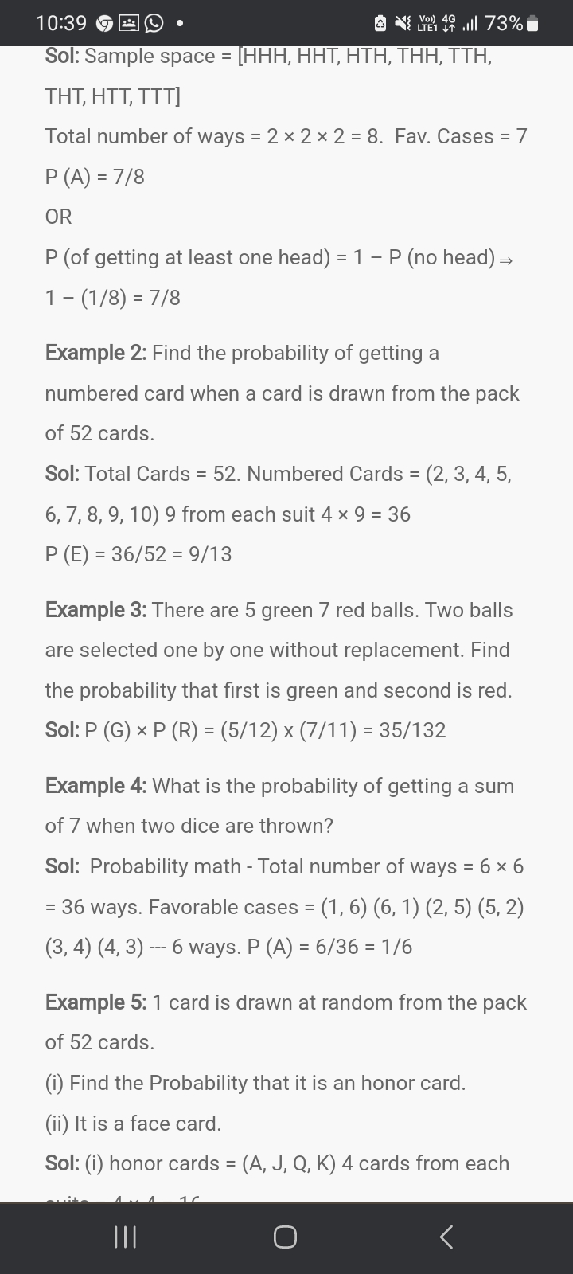

2)

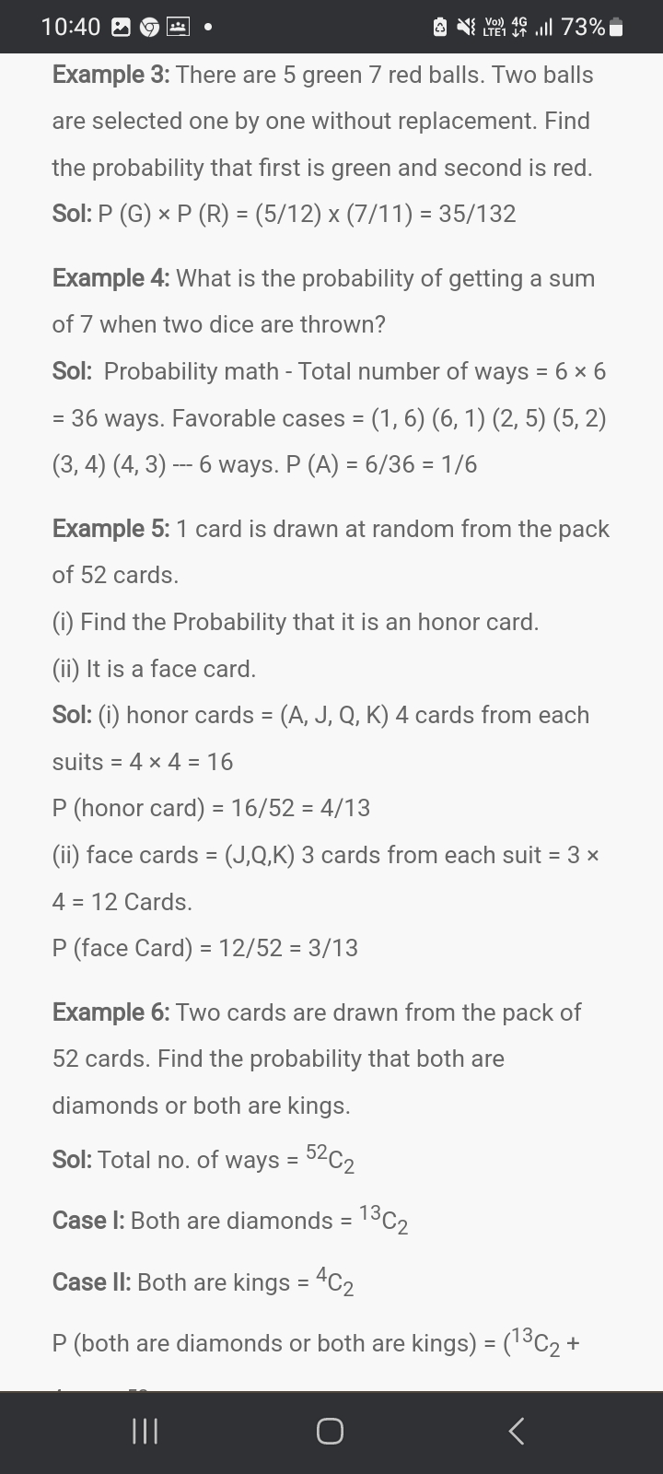

**Probability distribution: binomial distribution:**

**p(x)= ncx * px * (1- p)n – x**

3) Fifteen management graduates cross all hurdles and reach the final phase of a selection process for the recruitment of management trainees by a company. The final phase is an interview and we can gather from past data that, on an average, only 12% of the candidates qualifying for the interview get the job. Determine the following probabilities.

(Assume that there is no restriction on the number of management trainees to be recruited).

1. What is the Probability that exactly 5 candidates get the job?
2. What is the Probability that fewer than four candidates get the job?

4) The owner of a bookshop has observed that the Probability that a customer who is browsing through books will make a purchase is 0.3. Suppose that 15 customers browse through books in the section “Probability and Statistics” each hour. Determine the following probabilities, Probability that at least one browsing customer will make a purchase during a specified hour?

5) If 30% of a population owns their own homes, what is the probability that a sample of 7 from this population will contain exactly two homeowners?

6) The output of a production process is 10% defective. What is the probability of selecting exactly two defectives in a sample of five?

7) A company has analyzed its past data and found that 4 out of every 54 projects financed by it have succeeded and have given abnormal returns. It has 12 projects under consideration at the moment. Assume that the past trend is likely to be repeated in future.

i) What is the probability that only 4 projects will succeed?

ii) What is the probability that none of the projects will succeed?

8) E-store.com has set up a new electronic department store on the internet. It has observed that customer who visits its site and browses for more than a minute is likely to buy something one out of four times. There are approximately 10 customers in an hour how visit that site for more than a minute.

i) Find the out the probability that at least six customers will buy something from the store in a specified hour?

ii) Find out the probability that no customer will buy anything from the store in a specified hour?

9) A stock broker has identified that 80% of the telephone calls he receives during business hours are for buying or selling securities and rest of the calls are for other purposes.

What is the probability that out of the first 10 telephone calls received in a day exactly five calls are for trading in securities?

What is the probability that out of the first 10 telephone calls received in a day more than seven calls are for trading in securities?

1. 2% of cakes are brown. If 6 cakes are packed, at random, into a box, what is the probability that none are brown?
2. A jury consists 12 citizens, selected at random, from a population which 55% female. What is the probability that the jury will have at least two female members?
3. Suppose a batter ( in baseball) gets a hit with a probability of 0.3, and gets out of the rest of the time. What is the probability of that batter getting 0 hits in 10 at bats?
4. What is the probability of flipping a fair coin eight times and getting only two heads?
5. Consider the following data relating to the share price of ABC Ltd.

|  |  |  |  |  |  |
| --- | --- | --- | --- | --- | --- |
| Price (Rs./Share) | 10 | 20 | 33 | 45 | 65 |
| Probability | 0.10 | 0.30 | 0.40 | 0.15 | 0.05 |

1. Calculate expected price of the share of ABC Ltd.

|  |  |  |  |
| --- | --- | --- | --- |
| Event | P(S) | RB (%) | RC (%) |
| Boom | 0.30 | 10 | 15 |
| Normal | 0.50 | 6 | 10 |
| Slow | 0.20 | 5 | 5 |

1. From the below find out Expected Returns, Variance & Co-variance.

0.

**Theory Questions:**

1. Write Difference between Primary Data and Secondary Data.
2. What is Statistics? Explain Descriptive Statistics and Inferential Statistics?
3. Importance of Statistics.
4. Define – Variance
5. Define Sample and Population.
6. Explain Cluster Sampling and Stratified Sampling
7. Define Types of Analysis. (Qualitative Analysis & Quantitative Analysis)